Settings up a new environment
- Verify Prerequisites
  - Servers
  - Software Version
  - Service Accounts
  - Access
  - Connectivity
  - External Resources
    - SQL Server
    - Document Management (OnBase)
    - BRE (Corticon)
    - External Connections (IOP, CBOSS, SI Connections, etc.)
    - Others…
- SQL Server – create the DB
  - DB Names:
    - PDMS: OH_PNM_<Environment>
      - Example: OH_PNM_E2E
    - Other databases required:
      - NPI
      - OH_PNM_CONV1
      - NE_PDMS_EXL01
    - (We add these with Cherwell tickets)
  - Verify Database Settings with the DBAs
    - Initial Sizes
    - Recovery Mode
    - Change Data Capture (CDC)
    - Etc.
    - (DB Team should have this information)

- App server –
- Verify the Jenkins Server is in the Local Administrators group (this is how Jenkins will connect and push updates and stop/start services). The current Jenkins Server name is: MAXCORP\IP-0A7608C2$
- Make sure the Jenkins server is in the Inbound Security rules for RPC (Ports 135-139) and SMB (445)
- Install IIS with necessary Options
  - ASP.NET 4.x
  - WCF if Web API
  - Tracing
  - IIS 6 Management Compatibility
  - IIS Management Scripts and Tools
- Create the application pool and the application directories
  - Naming: OH_PNM_SVC_<Env>
  - Managed Pipeline = Integrated
  - .NET = 4.0
  - For the Web Application Use Network Service for App Pool Identity
- Set any special IIS Settings at the IIS level
  - uploadReadAheadSize
- Update the Appsettings.dll.config at C:\PDMS\JobService and add the new DB
- Install the new jobservice [This is now replaced by Task Scheduler Tasks.]
OH_PNM_SVC_<ENV>
C:\Windows\Microsoft.NET\Framework\v4.0.30319>installutil /servicename="Job Serv
ice Integration2" C:\PDMS\JobService\JobService.exe "-d IntDB2 -n Job Service In
tegration2"
For the DB name, specify the new name added in appsettings, which in this case is IntDB2
  - Create a Backup Directory: C:\Backup\OH_PNM_E2E\ (This should be changed to D:)
- Task Scheduler and Tasks
  - Import Tasks into the Windows Task Scheduler
  - Update the properties during the import
  - Set the service account credentials.

- Web/WebAPI server
  - Verify the Jenkins Server is in the Local Administrators group (this is how Jenkins will connect and push updates and stop/start services). The current Jenkins Server name is:
  - Make sure the Jenkins server is in the Inbound Security rules for RPC and SMB
  - Create the Application Pool and Application
  - Set the Application Pool to use Network Service (this is important for SSRS Reports to work. Also in the SSRS Application setup the Network Service (Machine Account name) needs to have the access to run the parametrized reports
    - AppPoolWeb=OH_PNM_PROD
    - AppPoolWebAPI=OH_PNM_API_PROD
    - AppPoolSvc=OH_PNM_SVC_PROD
  - Create the new local file store folder (this is controlled by the AppSettings settings)
    - D:\Projects\Deployments\PDMS\<Environment>\FileStoreLocal
    - In Prod: D:\PDMS\Web App\Prod\FileStoreLocal
  - Import the Certificates for Web and Web API
    - Public Certificates for any partners that will connect to the WebAPI
    - Private Certificate for the outbound calls that require mutual-TLS
    - Make sure the Private Certificate Private Key is accessible (Read access is fine) by the account running the Web or other processes that will make use of it. This is done using the MMC Certificates snap-in.
- Code changes
- Update C:\Projects\Modern\PDMS\SqlScripts\AppSettings\UpdateAppSettings.sql and add the new environment. Run the script for new database. Checkin the changes
- Add the modified appsettings.config, web.config and pubxml files. Checkin the changes
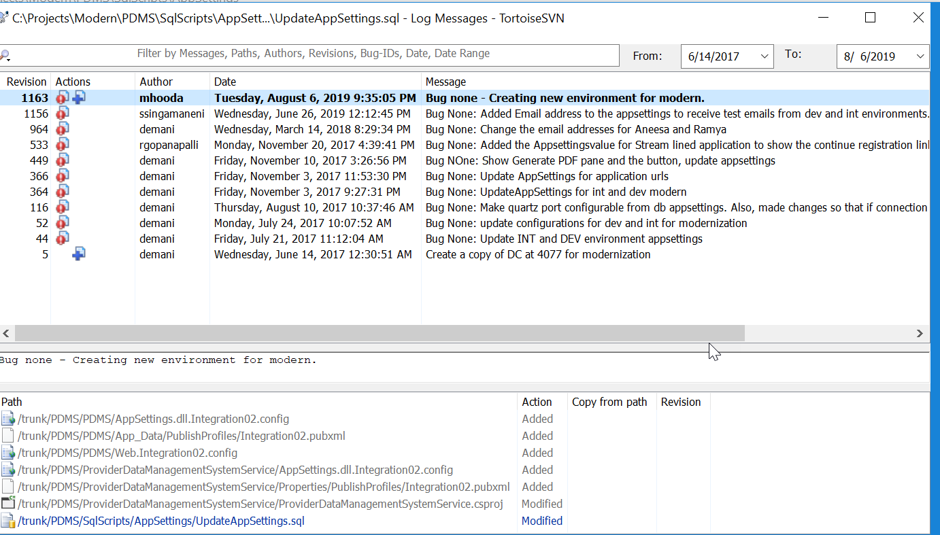

For example of the files changed when using the E2E files as a seed for the Prod Environment (copy and rename the files, replacing E2E with PROD in the filename and then edit each file and update the contents as appropriate. The check-in to SVN. Note that the AWSE2E portion of the filename matches the profile designation in the MSBuild option within Jenkins.

\trunk\PDMS\PDMS
AppSettings.dll.AWSE2E.config
Web.AWSE2E.config

\trunk\PDMS\PDMS\App_Data\PublishProfiles
AWSE2E.pubxml

\trunk\PDMS\PDMSWebAPI
Web.AWSE2E.config

\trunk\PDMS\PDMSWebAPI\Properties\PublishProfiles
AWSE2E.pubxml

\trunk\PDMS\ProviderDataManagementSystemService\Properties\PublishProfiles
AWSE2E.pubxml

C:\SVN\PDMS\ProviderDataManagementSystemService
AppSettings.dll.AWSE2E.config

- Create new Jenkins project and configure for the new environment. Click on New Item and select the option to copy from existing environment. After the build is created, all environment variables need to be changed, publish profile (command line arguments) need to be changed. The new job service restart command need to be added in post-build actions
psexec -accepteula %ServiceServer% net stop "Job Service Integration2"

- Run the following script OHPNM\PDMS\SqlScripts\DataConversion\MITS Conversion\OhioDataConversion\EnvSetUpScripts\SetUpAdminUser.sql in the new db
- Executing this stored procedure create admin account with username = ‘admin’ with parameter you have passed as arguments --exec SetUpAdminUser <<password>>. After this please check if db has a record for select * from aspnet_users where userid = ‘5D0689A8-D885-4211-B9FD-56757474AB4D’ and username = ‘admin’

